NFS Manufacturing, Business Process - Initial Intake

Friday, October 28, 2022

8:06 AM

Main Presenter - Erick Flesey

**NFS Manufacturing App Proof of Concept**

* Overview
  + NFS Manufacturing has been doing things same way for last 30 years, Erick hopes to help introduce modern business practices and technologies into it.
  + Working on an app to take care of the 4-5 page process to send out packages:
  + 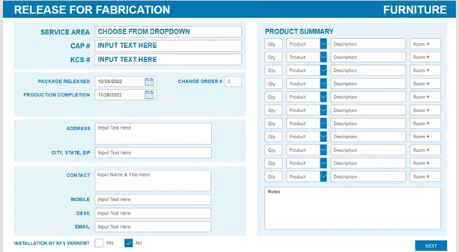
  + Erick has received a green light to take this on as his own project and is motivated to do so
* Missing Features/Work to be done
  + App uses "fake" UI, dropdowns are not functional, plans on looking into how to fully use Power Platform
  + Missing a data source, needs more product descriptions/content
* Recommendations:
  + Rudi recommended using Sharepoint as a data source
    - Want to take advantage of the free standard connectors to avoid cost build up from multiple premium user licenses
    - Also recommended consulting Microsoft's provided training on Power Platform for additional resources
  + Brittany recommended consulting some tutorials, including Shane Young, Reza Dorrani, and April Dunnam on Youtube.
    - Also mentioned possibly using AI software that can take a proof-of-concept UI image and create a functional app, including working dropdowns, fields, and more